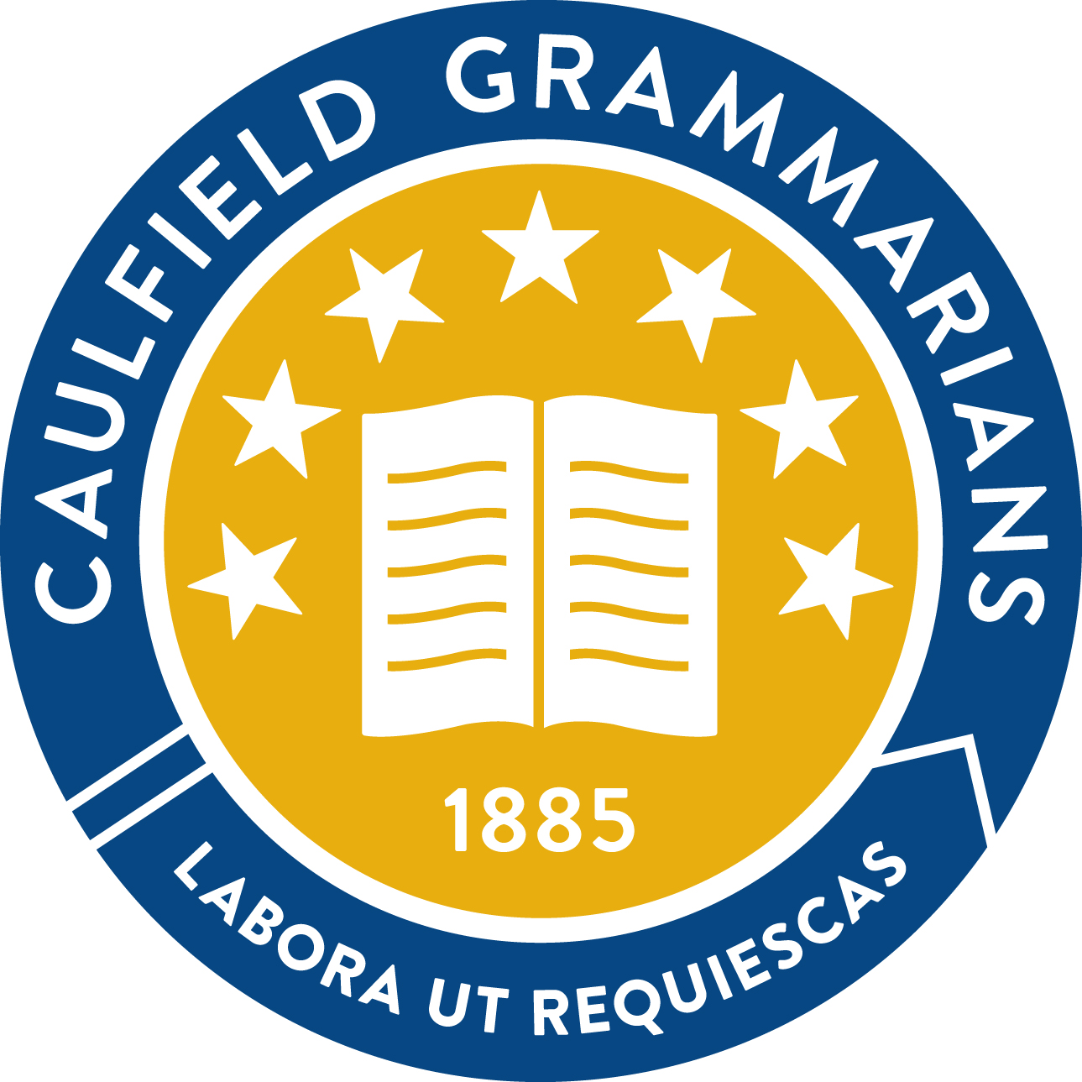

NOTICE OF SPECIAL MEETING

Meeting to be held on 27 June 2022

at 6:30pm

via Zoom
A special meeting of the Members of the Caulfield Grammarians Association Inc. (CGA) is called on resolution of the Committee in accordance with the current rules of the Association to consider the following special resolution:
That revisions to the Rules of the Caulfiled Grammarian’s Association Inc as documented in the attached annotated rules be approved and the Act Secretary be authorised to lodge the adopted revision with Consumer Affairs Victoria.

Background
The CGA is an incorporated association under the Associations Incorporation Reform Act 2012 (the Act). Consumer Affairs Victoria is the regulatory authority and reporting organisation for the CGA’s obligations under the Act.
The Act enables associations to adopt a set of model rules or create their own to suit their circumstances. An association with its ‘own rules’ must address the 18 mandatory items in Schedule 1 of the Act and, if relevant, the five optional matters. If the optional matters are not included, they are deemed not to apply to the association. Furthermore, if an association’s rules do not address the mandatory items, the model rules are deemed to apply. The CGA has adopted its ‘own rules’ - the current version is available here.
The CGA’s current rules were adopted in November 2016, but have not been substantially reviewed or revised since 2014. It is considered good governance for associations to review their rules every three years to ensure their currency. Therefore, the Committee conducted a comprehensive review of the current rules and identified a number of consquential changes to ensure they reflected requirements under the Act, best practice as established by the model rules and current operational practices and strategic objectives of the CGA.

Revision process
At its meeting of 14 February 2022, the Committee reviewed the currency and adequacy of the rules against the requirements of the Act and endorsed the proposal to seek certain changes. A revised draft of the rules was reviewed out of session and at the 4 April 2022 meeting and, following incorporation of the committee’s requested changes, circulated to key stakeholders for further feedback. Attachment 1 contains an annotated version of the proposed changes to the rules.

Summary of proposed changes
This following table outlines the matters listed in Schedule 1 of the Act that must be reflected in the rules of incorporated associations and a summary of the changed content in the attached revision.

Schedule 1 Matter | Current rule clause | Proposed change
1 The name of the incorporated association. | Preamble | No change
2 The purposes of the incorporated association. | Preamble | Update to reflect current strategic mission and purpose
Membership
3 The qualifications (if any) for membership of the incorporated association. | 3.1 – 3.5 | Change to align with current practices (eg clauses relating to conferral, insignia and induction that are no longer performed).  Streamline wording relating to eligibility for each class of membership and establish practices for nomination and conferral of membership to be determined by the Committee. Membership and Awards Sub-Committee maintained as per current rules.
4 The entrance fees, subscriptions and other amounts (if any) to be paid by members of the incorporated association. | 5 | No material change
5 The rights, obligations and liabilities of members. | 4 (benefits) | Introduce powers of the association and specify the rights, obligations and liabilities of members under the Membership section as per the model rules
6 Provisions for the resignation of a member or cessation of membership. | 3.6 | No material change
7 The procedure (if any) for the disciplining of members and the mechanism (if any) for appearances by members in respect of disciplinary action taken against them. | 3.6 | No material change
8 The grievance procedures for settling disputes under the rules between the incorporated association and any of its members or between a member and any other member. | 17 | No material change
Management and record keeping
9 The name, membership and powers of the committee or other body having the management of the incorporated association (in this paragraph referred to as the committee) and—  (a) the election or appointment of members of the committee;  (b) the terms of office of members of the committee;  c) the grounds on which, or reasons for which, the office of a member of the committee becomes vacant;  (d) the filling of casual vacancies occurring within the committee;  (e) the quorum and procedure at meetings of the committee. | 8 and 9 | - Increase maximum consecutive terms of the President to three. No change to cooling off period between holding office  - Remove restriction that one general member be over 35 and replace with statement regarding factors to be considered in ensuring Committee diversity  - Remove the school representatives (ie prior year school co-captains) as members of the Committee  - Replace clauses and references that classifies all committee members as “office bearers”, including general members and the Younger Past Students Representative  - Introduce functions, powers and duties of the committee as per the model rules, including power of delegation and the method of recording delegations  - Introduce the powers and duties of the office bearers as per the model rules, but maintain distinction between Act Secretary and Honorary Secretary  - Change the rule on sub-committee formation to be on resolution of the Committee rather than being a reserve power of the President  - Introduce use of technology at Committee meetings as per the model rules and the Act  - Introduce sections from the model rules where the current rules are silent (eg conflicts of interest and taking leave as a Committee Member)
10 The procedures for the appointment and removal of the secretary of the incorporated association. | 8.6 | No material change
11 The custody of records, securities and other relevant documents of the incorporated association. | 11.4 | Minor change to reflect model rules
12 Provisions for the custody and use of the common seal (if any) of the incorporated association. | 18 | No material change
13 Provision for members to have access to, and to be able to obtain copies of, the records, securities and other relevant documents of the incorporated association. | 3.7  11.3 and 11.4 | Minor change to reflect model rules
14 The preparation and retention of accurate minutes of—  (a) general meetings of the incorporated association; and  (b) meetings of the committee or other body having the management of the incorporated association. | 7.8 | Minor change to reflect model rules
15 Provision for members to have access to, and to be able to obtain copies of, minutes of general meetings of the incorporated association, including financial statements submitted at a general meeting. | 7.8 | Minor change to reflect model rules
16 Right of access (if any) by members to minutes of meetings of the committee, including any terms and conditions subject to which access may be granted. | 9.1.5 | Minor change to reflect model rules
Meetings
17 The intervals between general meetings of members of the incorporated association and the manner of calling general meetings. | 7 | Minor change to reflect model rules
18 The quorum and procedure at general meetings and whether members are entitled to vote by proxy at general meetings. | 7 | Introduce the use of technology at general and special meetings in accordance with provisions within the Act. Other minor changes to reflect model rules.
19 The time within which, and the manner in which, notices of general meetings and notices of motion must be given, published or circulated. | 7 | Minor change to reflect model rules (eg introduce separate section on the giving and receipt of notices including via email)
Funds
20 The sources from which the funds of the incorporated association are to be or may be derived. | 11.1 | No change
21 The manner in which the funds of the incorporated association must be managed and, in particular, the mode of drawing and signing cheques on behalf of the incorporated association. | 11.2 and 11.5 | Minor change to indicate that the responsibilities of the Honorary Treasurer as per model rules and current operational practice
Alteration of rules
22 The manner of altering and rescinding the rules of the incorporated association and of making additional rules. | 16 | No change
Winding up and dissolution
23 The disposition of any surplus assets on the winding up or dissolution of the incorporated association. | 19 | Minor change to stipulate that on winding up, the School must use surplus funds in accordance with the CGA’s purpose
Matters in addition to those required
Definitions | 1.1 | Some changes required to reflect current practice (eg the Executive Director is no longer employed by the School, the definition of “friends” should not be limited to residents of Victoria given the School’s partnerships and alumni interests being represented interstate and internationally).  Move matters of definition located in the body of the rules (eg Fellowship) into the definitions.
Insignia | 2 | Make approval of the CGA crest/insignia a power of the Committee in consultation with Members. Develop an operational policy to define the process to affix the crest and seek approval to change it.
Publications | 12 | Remove from Rules and develop as an operational policy
Branches, affiliated clubs and societies | 13 and 14 | Streamline and remove distinction between restricted and unrestricted affiliates
Service awards | 15 | Streamline and make generic, while removing Caulfied Grammarian of the Year (as this is not currently awarded)
Other changes:
- Implement the structure and numbering format of the model rules.
- Introduce gender inclusive pronouns throughout.

Attachments
- Revised Rules of Caulfield Grammarians’ Association Inc. Reg No. A0024880Z (changes annotated)

