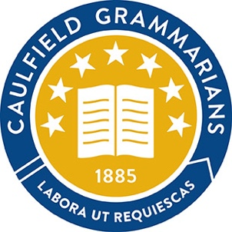

2022 CGA COMMITTEE NOMINATION FORM

The Executive Director
cgaexecutive@caulfieldgs.vic.edu.au
Caulfield Grammarians’ Association
PO Box 25
ELSTERNWICK, VIC 3185

We the undersigned wish to nominate

___________________________________________________________________________

for the position of

___________________________________________________________________________

on the Committee of the Caulfield Grammarians’ Association Inc.

Proposer:___________________________________________________________________

Seconder:___________________________________________________________________

Nominee:___________________________________________________________________

Date:_______________________________________________________________________

